# IDENTIFICATION AND SOLVING OFSIMPLE REAL LIFE PROBLEMS

**EX 1:** Draw flowchart and write algorithm, pseudo code

1. **CALCULATING ELECTRICITY** **BILL**

**AIM**

To draw flowchart and write algorithm, pseudo code for calculating electricity bill.

**ALGORITHM:**

STEP 1: start

STEP 2: Enter this month unit and previous month unit.

STEP 3: unit =this month unit – previous month unit.

STEP 4: check unit <= 100 , if true ,no amount pay else move to next step.

STEP 5: check unit >100 && unit<=200 if true print the process of condition.

STEP 6: check unit >200 && unit<=400 if true print the process of condition.

STEP 7: check unit>400 if true print the process.

STEP 8: total amount = amount +FTC+DC

STEP 9: print total amount

STEP 10: stop

**FLOW CHART:** 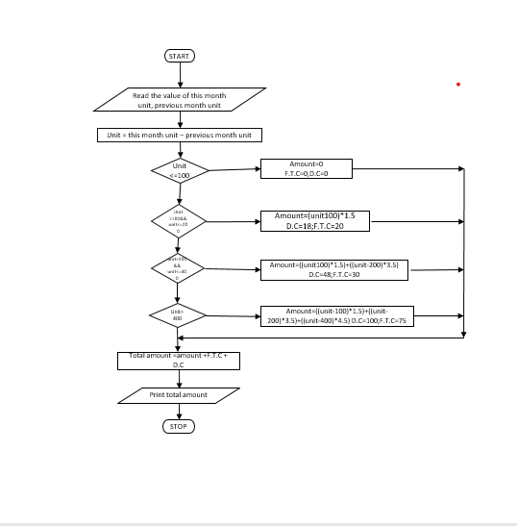

**PSEUDO CODE:**

BEGIN

GET values of this month unit, previous month unit

COMPUTE unit= this month unit-previous month unit

IF unit<=100

No amount to pay

ELSE

Move to next step

ENDIF

IF unit>100 && unit<=200

PRINT the process of condition

ELSE

Move to next step

ENDIF

IF unit>200 && unit<=400

PRINT the process condition

ELSE

Move to next step

ENDIF

IF unit>400

PRINT the process condition

ELSE

Move to next step

ENDIF

COMPUTE total amount = amount + FTC + DC

PRINT total amount

END

**RESULT:**

Thus the algorithm, pseudo code and flowchart is written for the given problem.

**2. CALCULATING SINE SERIES:**

**AIM**

To draw flowchart and write algorithm, pseudo code for calculating sine series.

**ALGORITHM:**

**STEP1:** Start

**STEP2:** Read the number of items

**STEP3:** Initialize i=1, series=x

**STEP4:** if i<=n, sum = ((-1) **1)*(***(2i+1))/(2i+1)!

**4.1:** series=series + sum

**4.2:** increment i value by i=i+1 goto step 4

**STEP5:** if condition is false

**STEP6:** print series

**STEP7:** stop

**FLOWCHART:**

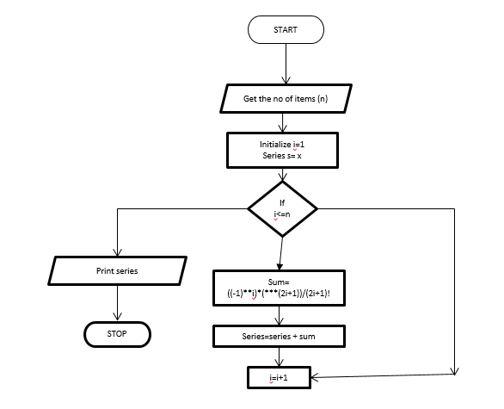

**PSEUDO CODE:**

START

GET value of x,n

x must be in degree

INITIALIZE i=1,s=-1**I,sine=0

Import math

IF i<=n THEN

Convert x to radian using formula

CALCULATE

Sine=sine+y**(2*i=1).factorial(2*i+1)*s

i=i+1

ELSE

Display sine

STOP

**RESULT:**

Thus the algorithm, pseudo code and flowchart is written for the given problem.

**3.ELECTRICAL CURRENT IN 3 PHASE AC CIRCUIT:**

**AIM**

To draw flowchart and write algorithm, pseudo code for calculating electric current in 3 phase ac circuit

**ALGORITHM**

**STEP1:** start

**STEP2:** read the value kw, v

**STEP3:** to find I calculate (1000*kw)/(1.732*v)

**STEP4:** display the value I

**STEP5:** stop

**FLOWCHART:**

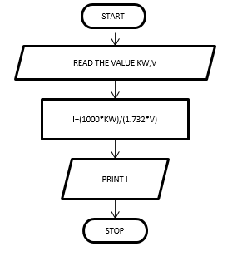

**PSEUDO CODE:**

START

READ the value of power factor

READ the value of I

READ the value of v

CALCULATE p = $\sqrt{3}$*pf*I*V

DISPLAY the result of p

STOP

**RESULT:**

Thus the algorithm, pseudo code and flowchart is written for the given problem.

**4.WEIGHT OF STEEL ROD**

**AIM**

To draw flowchart and write algorithm, pseudo code for calculating weight of steel rod.

**ALGORITHM**

**STEP1:** start

**STEP2:** enter the number of rods (N.R)

**STEP3:** if N.R==0 yes: 3.1, 3.2 no: go to step 4

**3.1:** total weight is zero

**3.2:** go to step 6

**STEP4:** initialize total weight is 0, i=1

**STEP5:** if N.R >=i, yes: move to 5.1, no: go to step 6

**5.1:** read the value D, L

**5.2:** w= ((D*D)*L)/162

**5.3:** total weight = total weight + w

**5.4:** increment i , i++

**STEP6:** print total weight

**STEP7:** stop

**FLOWCHART:** 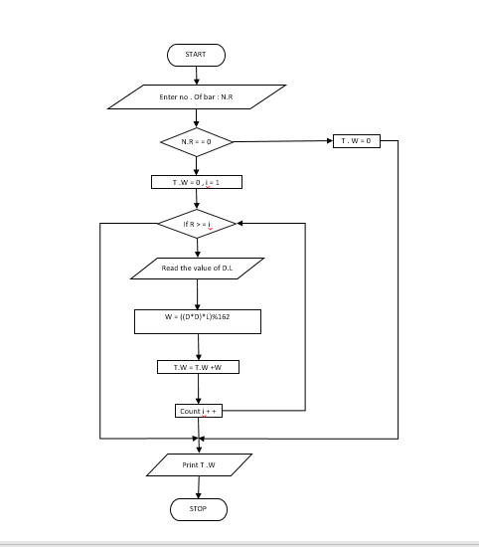

**PSEUDO CODE:**

START

GET number of iron rods as n

INITIALIZE I=0 total=0

If i<n THEN

Get diameter of rod D

CALCULATE unit weight using formula D**2/16

GET number of rods with D

CALCULATE weight of rod using formula, number of rods*D* unit weight add weight to total

i=i+1

ELSE

Display total weight of rod

STOP

**RESULT:**

Thus the algorithm, pseudo code and flowchart is written for the given problem.

**5.RETAIL SHOP BILLING**

**AIM**

To draw flowchart and write algorithm, pseudo code for calculating retail shop billing.

**ALGORITHM:**

**STEP1:** start

**STEP2:** read the bill number

**STEP3:** enter the customer name,address

**STEP4:** get the total number of item purchased

**STEP5:** if N==0, yes: 5.1,5.2 ; no: go to step 6

**5.1:** sum=0

**5.2:** go to step 8

**STEP6:** initialize i=1,sum=0

**STEP7:** if i<=N ; yes: move to further step; no: go to step 8

**7.1:** read the value of the product

**7.2:** sum =sum + v

**7.3:** increment of i, i++

**STEP8:** if sum>2000, yes:8.1, no: goto step 9

**8.1:** sum *0.20=DA(discount amount)

**8.2:** total amount= sum-DA

**8.3:** print total amount and step 2 and step 3

**STEP9:** print sum

**STEP10:** stop

**FLOWCHART:**

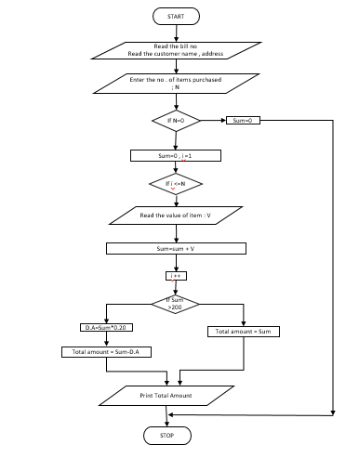

**PSEUDO CODE:**

START

GET the bill number

GET the customer name , address and phone number

GET the value of total number of items puechased (n)

INITIALIZE I = 0 , total = 0 and sub total = 0

If (i<n)

THEN

GET item name , price , quantity and discount

CALCULATE subtotal = quantity * price – discount

CALCULATE total = total + subtotal

INCREMENT the value of i

ELSE

GET the GST value

CALCULATE total = total + subtotal

INCREMENT the value of i

ELSE

GET the GST value

CALCULATE total bill amount = total + GST/100

DISPLAY the total bill amount

END IF

STOP

**RESULT:**

Thus the algorithm, pseudo code and flowchart is written for the given problem.

**6. WEIGHT OF MOTOR BIKE**

**AIM**

To draw flowchart and write algorithm, pseudo code for calculating weight of motor bike.

**ALGORITHM:**

**STEP1:** start

**STEP2:** get the type of motor cycle, M

**STEP3:** based on type M, choose weight as

**3.1:** if M=chopper, w=317 kg

**3.2:** if M=bobber, w=306kg

**3.3:** if M=cruiser, w=256kg

**3.4:** if M=scrambler, w=182kg

**STEP4:** else print as cannot find the weight

**STEP5:** print the weight

**STEP6:** stop

**FLOWCHART:**

**PSEUDO CODE:**

START

GET the type of motorcycle, M

IF M=chopper

PRINT w=317

IF M=bobber

PRINT w=306

IF M=cruiser

PRINT w=256

IF M=scrambler

PRINT w=182

ELSE

PRINT cannot find the weight

ENDIF

PRINT the weight

STOP

**RESULT:**

Thus the algorithm, pseudo code and flowchart is written for the given problem.

**7. STUDENT GRADE ANALYSIS**

**AIM**

To draw flowchart and write algorithm, pseudo code for calculating student grade analysis.

**ALGORITHM:**

**STEP1:** start

**STEP2:** read the number of students as N

**STEP3:** initialize i=1

**STEP4:** if i<=N yes: goto step5 no: go to step 15

**STEP5:** read the marks m1, m2, m3and name of students

**STEP6:** total=m1+m2+m3

**STEP7:** avg= total/3

**STEP8:** if avg>=90 && avg<=100 yes: 8.1,no: go to step 9

**8.1:** grade=A+

**STEP9:** if avg>=75 && avg<90 yes: 9.1, no: go to step 10

**9.1:** grade=A

**STEP10:** if avg>=50 && avg<75 yes: 10.1, no: go to step 11

**10.1:** grade=B

**STEP11:** if avg>=35 && avg<50 yes: 11.1, no: go to step 12

**11.1:** grade=C

**STEP12:** if avg <35 go to 12.1 else go to step 13

**12.1:** grade=D

**STEP13:** increment i

**STEP14:** print the name and grade

**STEP15:** stop

**FLOWCHART:**

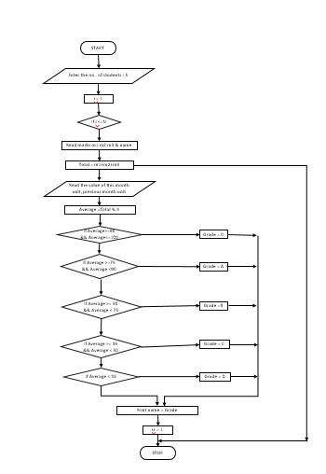

**PSEUDO CODE:**

START

READ number of students n

IF i< n THEN

GET student name , roll number m1,m2,m3

ELSE

BREAK

CALCULATE percentage using formula,(m1+m2+m3)/3*100

IF 100>=percentage >90 THEN

PRINT name, roll number, ”o+” STOP

ELIF 90>=percentage>80 THEN

PRINT name ,roll number, ”o +” STOP

ELIF 80>=percentage>70 THEN

PRINT name, roll number , ”A” STOP

ELIF 70>=PERCENTAGE>70 then

Print NAME, ROLL NUMBER “B” STOP

ELIF

PRINT name, roll number “fail” STOP

I=I+1

STOP

**RESULT:**

Thus the algorithm, pseudo code and flowchart is written for the given problem.